M2M intro challenge 1 CodeSys

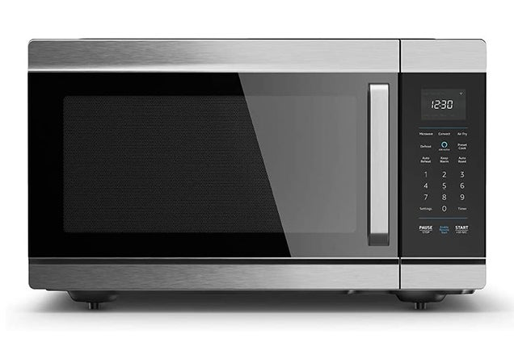

Semester 4 M2M

OvenProcess

Feb 06, 2023.

Student: Andre Sanao

Course: Smart Industry

Table of Contents

Introduction 4

Flowchart 5

Conclusion 6

**Acronyms**

*Table 1 – List of acronyms used throughout the report*

|  |  |
| --- | --- |
| **Acronym** | **Meaning** |
| ICT | *à*  Information and communication technologies |
| UI | *à*  User Interface |
| M2M | *à*  Machine to Machine |

Introduction

The assignment on which this document presents a small overview of M2M subject. In this subject, we will learn how code in a different software called CodeSys. The language used in this software is structured texts and together with it, it can be used to simulate hardware process. They are commonly used in fields such as manufacturing, transportation, and healthcare. In the following sections will provide the research and procedure of the assignment.

# Flowchart

To start off the assignment, we have to draw a state machine or a flowchart. I decided to draw a flowchart because it is easier and more abstract. The flowchart can be seen below. (Figure 1)

Figure OvenProcess Flowchart

As you can see in the flowchart, the process starts when power is on. During idle, you can switch between recipes before starting the heating process. Additionally, you can also turn the power on or off during switch recipe. After the recipe has been decided, the pizza will go inside the oven and the heating process will start until it is over. During this state, you can also turn off the power and the pizza will come out. After a certain amount of time, the pizza is ready to be unloaded and returns back to idle after loading the tray.

# Conclusion

To conclude this assignment, the assignment was entry level difficulty and it relates to technology course. I already know how to use CodeSys in my previous school but during that time I was using an older version so the UI changed a little bit. I first try to understand the code before implementing my code and it went well the first try. All in all I look forward for future assignment in this subject.